# Lab 10: Functions – Draw Triangle Pyramid

Academic Honesty

* The work you turn in is to be your work, not copied from someone else, from the web, or generated by a program.
* Never allow anyone access to your files.
* Never give anyone your password.
* Never share your USB memory or email your files to anyone else.
* Never give anyone a printed copy of your file or an electronic copy.
* Never allow anyone to copy your work.

Purpose

This lab will let us practice creating and calling a function.

## Functionality

* Your program will draw a triangle pyramid

## Implementation

* Create a function to draw a up triangle
* Create a function to draw a down triangle. These functions need the following parameters:
  + X location
  + Y location
  + Width
  + color
* Create a function to draw a line of triangles. Needs
  + X location to start the line at
  + Y location to start the line at
  + Width (Width of triangles in line)
  + Number (Number of triangles in line)
* Depending on your implementation you may need a second draw line function for the upside-down triangles
* Use a for loop to call the drawline function to draw the 5 lines of triangles, do this for both the up and down triangles.

## Sample Program

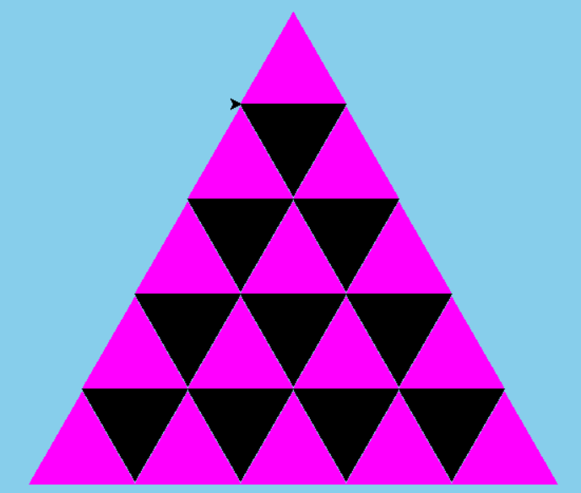

## Submitting your files

* Copy your .py file and move it to your X:\101Labs directory for grading.
* Make sure your file is named Lab10XY.py where XY are your initials
* Print your code, and submit it to your lab instructor at the beginning of your next lab class.

## Grade Breakdown

|  |  |
| --- | --- |
| **Points** | **Expectation** |
| 10% | Comments, listing program, your name, and explaining the code |
| 45% | Correctly creating and calling your function |
| 45% | Correctly draw the triangle pyramid |